

Stamford Downtown City Challenge Race Road Closures and Washington Blvd Detour for Sunday July 28th from 7:30 am to 1:00 pm

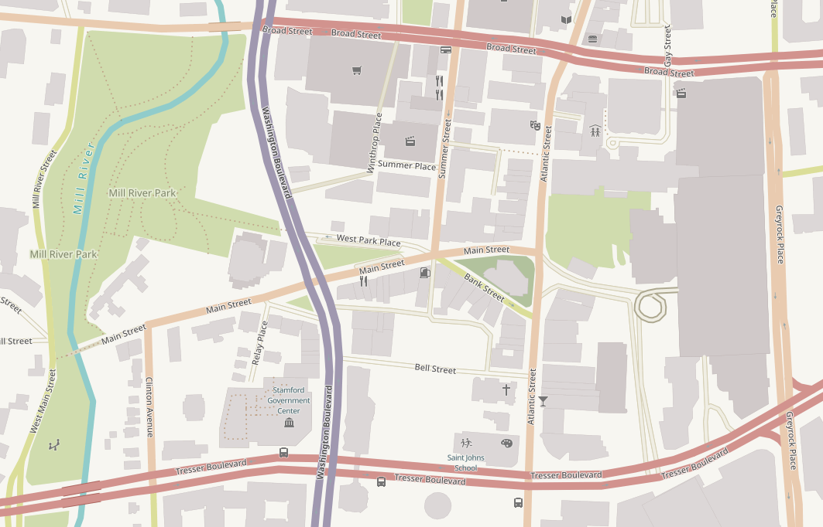

Legend:

Road closure

**Southbound Washington Blvd Detour**

**Northbound Washington Blvd Detour**

**Roads open to local traffic ONLY**