

Join the

National Educational Chess Association

in **Latham Park in Stamford Downtown**

**CHESS DAY- OPEN PLAY**

**FREE!**

Back by Popular Demand – A full outdoor season of CHESS:

**When: Saturdays, May 26, June 23, July 7 & 21, Aug 4 & 18 and Sept. 1, 2018**

**Where:**   **Latham Park in Stamford, CT**

GPS address[269 Bedford St, Stamford, CT 06901](https://www.bing.com/local?lid=YN873x15509448561450847983&id=YN873x15509448561450847983&q=Latham+Park&name=Latham+Park&cp=41.0570182800293%7e-73.5376968383789&ppois=41.0570182800293_-73.5376968383789_Latham+Park&FORM=SNAPST)

**Time: 1 pm to 3 pm**

Weather permitting

***Learn and Meet new players and help make Stamford the chess capital of Connecticut!***

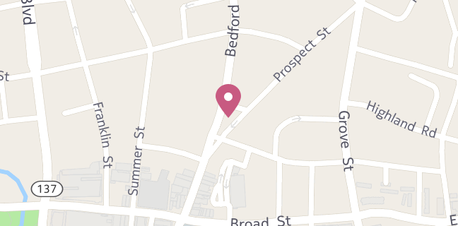



This event made possible by the

Stamford Downtown Special Services District in collaboration with

National Educational Chess Association  
For more info contact dssd@stamford-downtown, 203-348-5285

stamford-downtown.com

[necachess.com](http://www.necachess.com)